Ronnie Corpuz
CS 499 Milestone Two: Enhancement One
Software Design and Engineering
Artifact: Travlr Getaways
Dr. Sherri Maciosek, Ph.D.
5/22/2026

Artifact Description
Travlr Getaways is the artifact I have chosen to enhance as part of Enhancement One. It is a full-stack web application I developed in CS 465 Full Stack Development. It has both a customer-facing travel website and an Angular admin application. The customer-facing side displays travel-related information. The admin side allows an authenticated user to view, create, edit, and delete trips, while restricting access to admin features based on whether the user is logged in.
Travlr Getaways uses Express, Handlebars, Angular, Node.js, REST API routes, MongoDB, Mongoose, and JWT authentication. The main administrative functions include viewing trips, adding trips, editing trips, deleting trips, and protecting admin features through authenticated login.
I chose Travlr Getaways for Enhancement One in the Software Design and Engineering category because it represents one of my strongest full-stack projects. Specifically, Travlr Getaways shows how the front end, back end, API layer, database layer, and authentication layer interact to provide one complete application.
Reasons for Including the Artifact in My Portfolio
I included Travlr Getaways in my portfolio as evidence of my proficiency in several important areas of software development. Specifically, Travlr Getaways illustrates my ability to work with a full-stack application, integrate an Angular admin side with a RESTful API server using Express and Node.js, use MongoDB and Mongoose to manage data, and authenticate users to ensure secure access to admin functionality.
Additionally, Travlr Getaways aligns with my long-term career goals. I want to continue developing practical programming skills that relate directly to addressing real-world problems. Currently, I am involved in troubleshooting systems and interacting with various technical tools in my engineering role. Therefore, enhancing a full-stack application like Travlr Getaways provides additional evidence of how my Computer Science education can apply to technical problem solving in practical work settings.
Lastly, I selected Travlr Getaways because it currently works well, but there were still several ways the user experience and overall software quality could be enhanced. For this enhancement, I focused on relatively minor changes that would not disrupt the overall functionality of the original application.
Completed Enhancements
For this enhancement, I made improvements to validation, error handling, and admin user feedback in the administrative application for Travlr Getaways.
Before the enhancement, errors during the login process were logged to the console by the application. However, no user-visible feedback was provided if login failed due to missing required fields or invalid username and password. I modified the login process so users are now informed when required fields are missing through a user-visible feedback message.
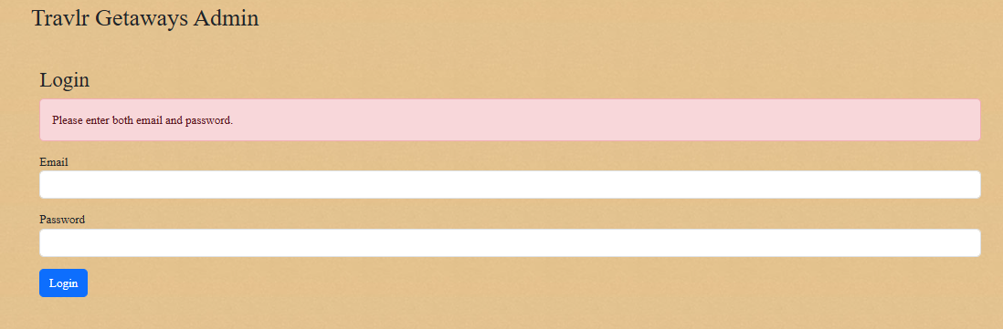
Login validation message for missing required fields

Additionally, I added a user-visible error message if the user enters invalid login credentials. Before making these modifications, I verified that valid login credentials still worked.
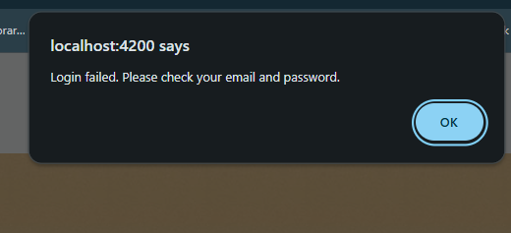
Login failed message for invalid credentials

Furthermore, I made enhancements to the Add Trip form. Before the modification, users could submit empty forms, which resulted in creating incomplete trip records in the database and caused display issues on the admin page. To resolve this issue, I implemented validation on the form before submission. Users now see a clear notification when a required field is left blank, and the trip is prevented from being submitted.

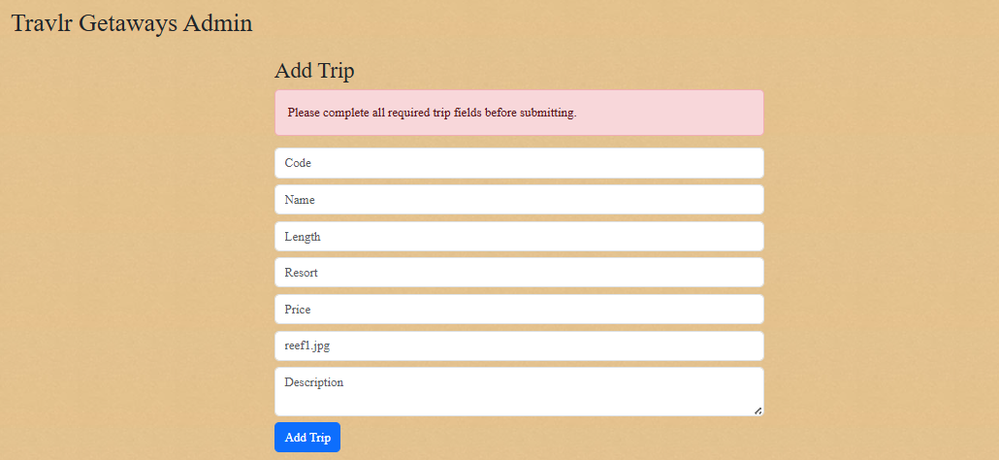
Add Trip validation message preventing blank trip submission
Finally, I improved admin feedback regarding trip actions. Users now receive clear success messages when they successfully perform available trip actions, such as creating a new trip, updating an existing trip, or deleting an existing trip. I also implemented error messages when an attempt is made to add or update a trip and fails. Overall, these modifications resulted in a more user-friendly and reliable admin interface.
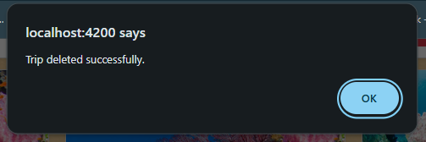
Delete Trip success feedback message
The files I enhanced are:
login.ts
login.html
trip-add.ts
trip-add.html
trip-card.ts
Improvements Made to the Artifact
By enhancing the Travlr admin interface with better feedback mechanisms and protection against incomplete entries in the Add Trip form, I improved both the usability and safety of the application for its admins. The application now relies less on console output or browser behavior to provide useful information about what happened with each action taken by admins. Furthermore, by implementing form-level validation before allowing a new trip entry to be stored in the database, I helped protect the integrity of the trip records by reducing display issues caused by incomplete records.
These enhancements contribute to Software Design and Engineering by improving usability, validation, error handling, and maintainability while keeping the fundamental architecture of the application intact. This reduced the risk of breaking existing functionality while still improving the quality of the application.
Alignment With Course Outcomes
These enhancements demonstrated several of the course outcomes identified in CS 499.
Professional Communication: These enhancements demonstrate professional communication by providing clear feedback to users. The documentation and narrative also describe design choices that help explain the work to both technical and nontechnical audiences.
Well-Founded Tools and Techniques: These enhancements demonstrate well-founded tools and techniques through the use of Angular, Express, Node.js, MongoDB, Mongoose, GitHub, and JWT authentication. They also demonstrate my ability to work within an existing full-stack project and enhance it without disturbing existing working elements of the application.
Security Mindset: These enhancements demonstrate a security mindset by introducing better validation methods and safer error-handling practices. By validating input values before accepting them and providing controlled user feedback, the enhancements reduce the chance of bad input causing problems within the system.
Based on my assessment of the progress made toward meeting the learning objectives outlined in Module One, I do not need to adjust my learning objective coverage plan at this point.
Reflection
The most significant thing I learned from completing these enhancements was that even small changes can strengthen an operational application. Initially, I approached this enhancement cautiously since Travlr was already working, and I did not want to make any unintended changes that might disable parts of the application. Due to this cautious approach, I limited my enhancements to input validation and user feedback instead of attempting any large-scale architectural changes.
Testing challenges came up during the Add Trip form testing. During testing, I determined that I could still submit blank fields on the form, which created incomplete trip records in MongoDB and affected the admin page display. Ultimately, I used MongoDB Compass to remove the incomplete record created during testing. After removing the record, I modified the Add Trip validation logic so that blank records cannot be created going forward.
A second testing challenge came up while testing login feedback. Although the validation message worked properly, I needed to determine whether there were differences between clicking the form's Login button and the navigation's Login button. After testing, I confirmed that the form validation worked correctly and that valid user credentials were still authenticated successfully.

AI Acknowledgement
I used generative AI only for grammar, sentence structure, and clarity corrections. All artifact selections, enhancement ideas, coding decisions, and final content are based on my own coursework and understanding.

